2023

Sampson County Parks & Recreation

Volleyball

Local Guidelines and Rules

**National Federation High School Rule Book** will be used with the exceptions listed below.

**1:00 DIVISIONS and AGE REQUIREMENTS**

1:01 Varsity Division: 10–12-year-old

Pro Division: 13–15-year-old

1:02 **Varsity Division:** Official Size and Weight

**Pro Division:** Official Size and Weight

**2:00 COURT SIZE / DIMENSIONS**

2:01 **10-12-Year-Old**: Net Height 6”7

**13-15-Year-Old:** Net Height 7’’3

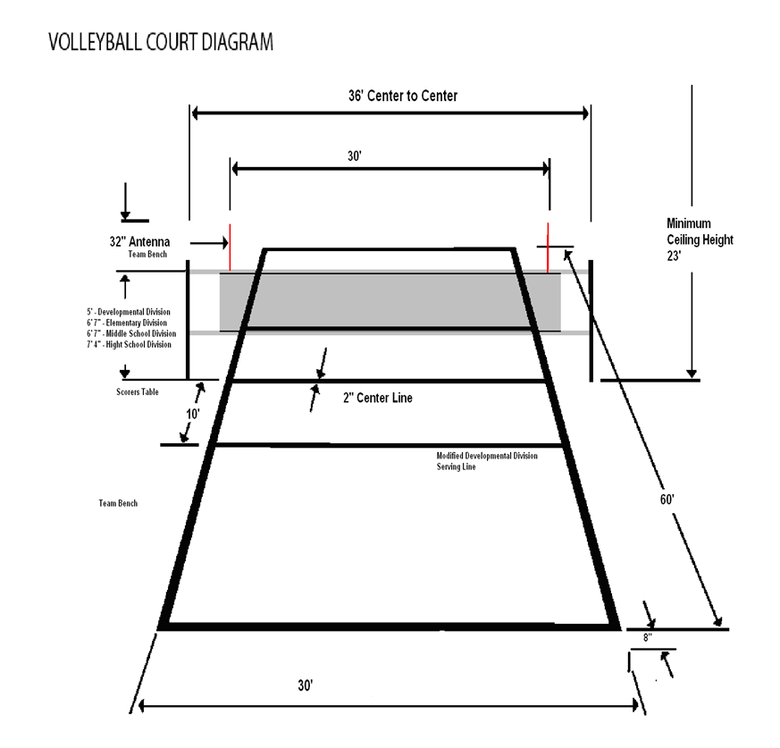

**3:00 PRACTICE:**

3:01 Coaches are expected to closely always observe their players to be certain that they do not become overly fatigued.

3:02 Practices will be limited to 1 hour and 30 minutes in length.

3:03 Practices must be over by 8:45 p.m.

3:04 Teams cannot practice more than two times per week during a game week and three times per week during a non-game week.

3:05 All Practices must be scheduled through the Recreation Department.

3:06 Penalty for violation: 1 game suspension of the head coach.

**4:00 PARTICIPATION**

4:01 **Participation Requirements**

1. All players will be required to play in at least **one (1) set of a match**. Each player should be given the opportunity to play but not limited to at least five (5) points and one (1) opportunity to serve.
2. Each child must have served by the end of the 3rd set. This rule will be monitored by the site officials.

**5:00 Substitutions**

5:01 Substitutions are allowed for any position on the court, players must have cycled through as server BEFORE being subbed out. After the first rotation through, players will then be allowed to sub in and out as their discretion. A complete rotation only applies at the beginning of the first set of each game.

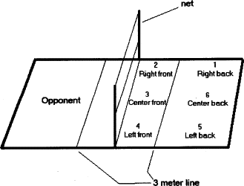

5:02 **Substitutions can only be made player for player per set.** This rule will be monitored by the site officials.

5:03 An injury or player misconduct may be subbed by any player if deemed appropriate by on-site officials. If it is felt that a team is attempting to gain a competitive advantage the sub will NOT be awarded.

5:04 There will be no cap on the number of substitutions a team may have in a game. Substitutions will be unlimited to the number of times a player may enter a game.

5:05 If a player re-enters the game, they must be in their original position in relation to their teammates and serving order.

5:06 **ALL PLAYERS PRESENT FOR THE MATCH MUST PLAY.** All players in good standing will play the minimum time required for their league.  **FAILURE TO COMPLY WILL RESULT IN TWO MATCH SUSPENSIONS FOR THE HEAD COACH. A SECOND OFFENSE WILL RESULT IN THE REMOVAL OF THE COACH FOR THE REMAINDER OF THE SEASON.**

Coaches are not obligated to play an individual the minimum time under the following conditions:

1. Player late for start of match or a no-show.

2. Player with unexcused absence from practice in the week before the match.

3. Player who has been a discipline problem.

4. Injured player who could have played the minimum time if uninjured.

5:07 A coach who suspends a player, according to rule, must get it approved by SCPR Staff prior to the game and notify the opposing coach and parents, prior to the start of the match.

\***Coaches who use the exceptions to the all play rule to gain an advantage over another team will be removed from the coaching staff**.

5:08 Any coach or player or spectator who is ejected from a game will be suspended **for the remainder of that game and the next scheduled game.** The suspension could be longer depending upon the severity of the infraction. Persons guilty of a second offense causing their ejection during the same calendar year shall be suspended for minimum of 365 days or longer depending on the infraction.

**6:00 GAME RULES**

6:01 **Set (Game)** -A series of plays and rallies between two teams that continues until one team reaches the pre-determined number of points.

**Match** - Consists of a series of sets. The match is completed when one team wins three (3) sets.

**Varsity** **Division and Pro Division:** All matches will consist of the best three (3) out of five (5) sets.

6:02 There will be a “coin toss” to determine which team will have the choice of serve or receive.

6:03 All matches will be scored using the rally point system. Sets will be played to 25. If a 5thset is needed, the set will be played to 10 points. No win by 2 rule.

When rally scoring is used, every service, except a replay or re-serve, results in a point.

* If the **serving** team wins the rally, it receives a point and continues to serve.
* If the **receiving** team wins the rally, it receives a point and the ball for service.
* If the serving team or player is assessed a penalty, the opponent is awarded a point and the ball for service.
* It is not necessary for the winning team to be serving at the time the winning point is scored.

6:04 A let serve (one that hits the net and goes over) will be considered a live ball-play on.

6:05 **10-12 ONLY** A server may serve from the regular base line or from the special marked line (5-feet in from the base line). If the server elects to serve from the special marked line and serves three (3) consecutive balls in, she must move to the regulation base line. All serves from the special marked line must be served underhanded.

6:06 After five (5) consecutive serves by the same team, the serve will be switched to the other team.

6:07 A server has 5 seconds to serve the ball after the whistle has blown.

6:08 If a ball volleyed by a member of Team A hits anything that is not part of the official court (i.e. rafters, ceiling) and returns to Team A’s side of the court, the ball **is live** and can be volleyed by another member of Team A (if touches are still available). The ball is considered dead if it lands on Team B’s side of the net and Team B is awarded the point and the serve.

6:09 Teams must have four (4) players present for a game to start or to continue.

***If Team A has less than 6 players, Team B is NOT required to match their number of players.***

6:10 Forfeit time is ten (10) minutes after the scheduled game time.

**FIRST GAME ONLY. Game time is forfeit time for the second game.**

6:11 Two (2) 60 second time outs will be allowed per match (5 sets).